**EXPLANATION OF DIFFERENT MODULES WITH SNAPSHOTS**

* This is Home page of our website
* Header provides clickable options for different pages of the website.

On the left side of header there is company logo and on the right there  
 is navigation bar.

* And then it has slideshow of 3 slides which changes with a set timer and also by the arrow head symbol (for better user experience), depicting company’s goals and motives. This slideshow is implemented by using carousel feature of bootstrap.

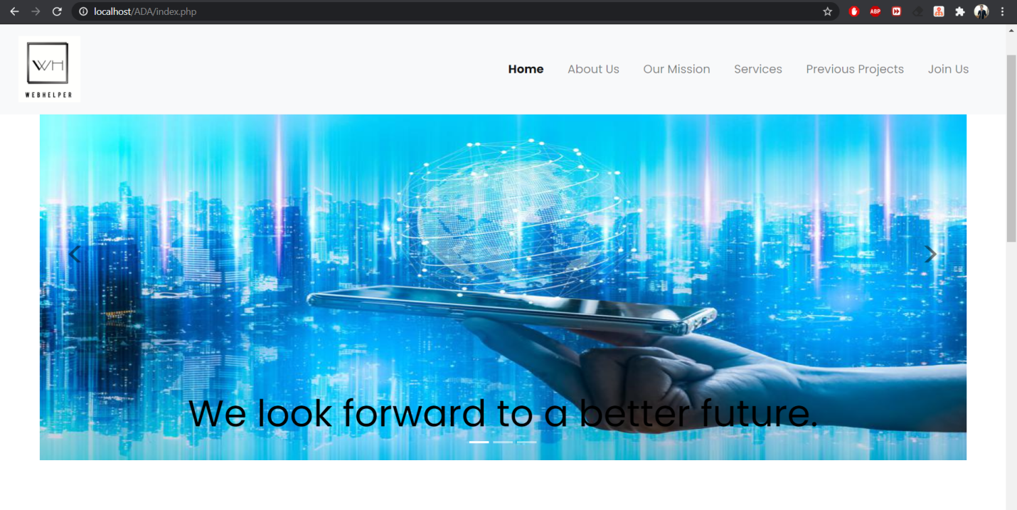

* Further down there is a tab, clicking on which displays a drop-down section containing a message about the idea behind this startup, and also a highlight of services we provide to our customers.
* Then there is option to connect with us on different social media platforms, namely Twitter, WhatsApp, and Instagram, as these are the most widely used social media platforms on the internet. On clicking on any of the 3 app icons, a redirect triggers which directly takes user to the profile’s feed or chat box of the respective web apps. We used these application’s API(s) to implement this feature.

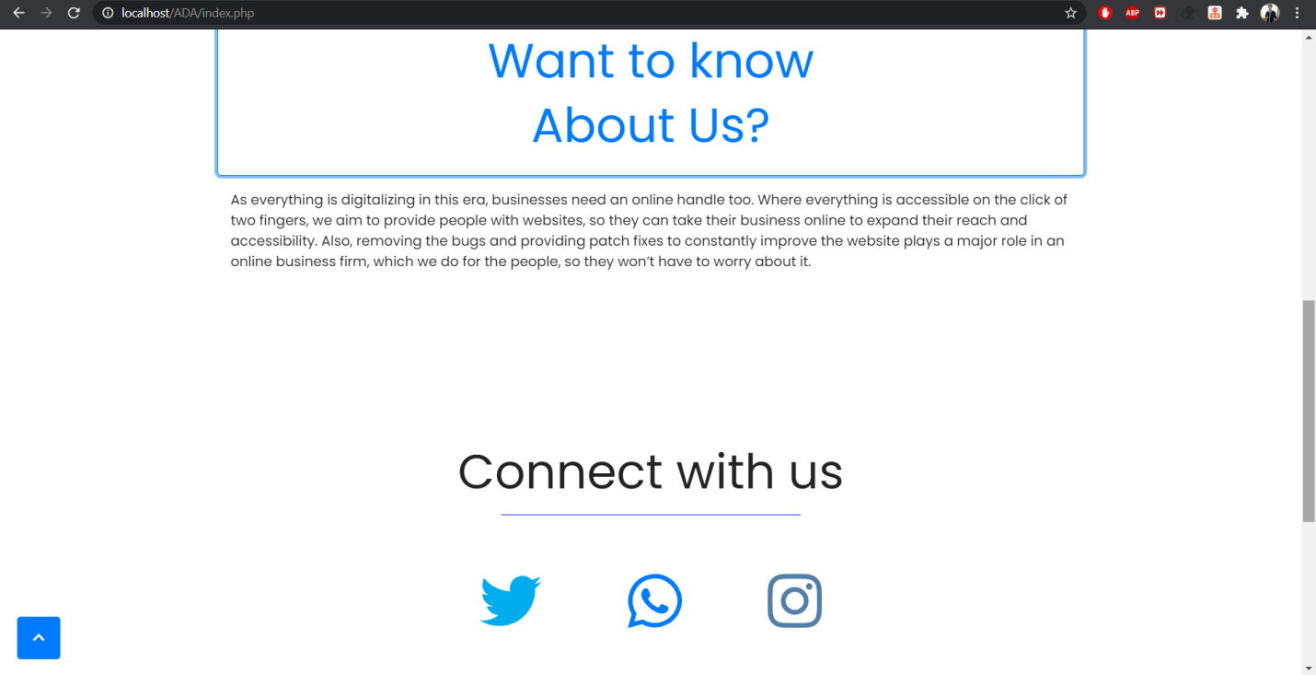

* Footer of the homepage has 3 fields, including postal address, email and phone numbers. Footer is implemented by using feature of bootstrap which helps to build footer of the webpage.
* Footer is same for all the pages in the website.
* On clicking on the email, it will redirect, and a new mail with a target address is created, without a body. Then user can mail us questioning anything regarding some sort of projects or quality products that we offered.
* On the bottom left corner there is an arrowhead facing up in all of the pages of the website. It is the scroll to top button which appears when the user has scrolled 100 pixels down from the top. It takes the user to the top of the page.

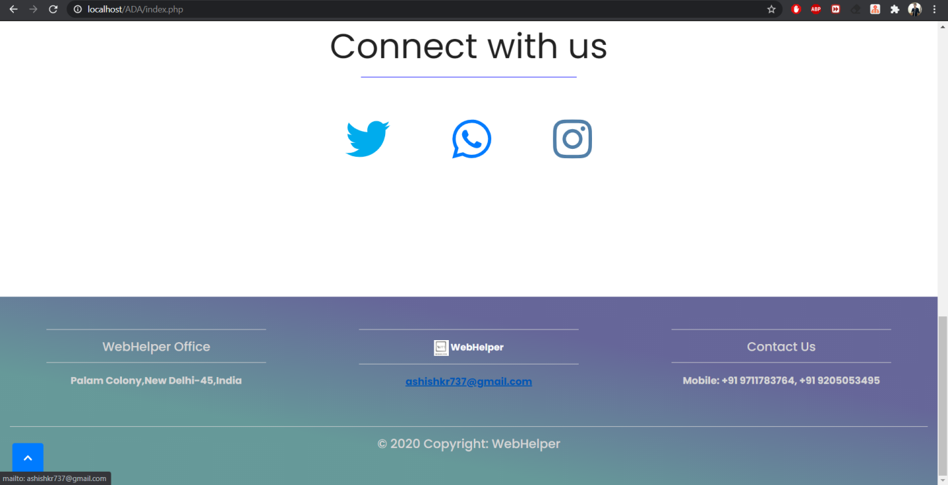

* This is About Us page of our website
* On clicking ‘About Us’ on the header of the website, a new page loads which consists the idea behind starting this company.
* There are 2 photographs of the persons behind this startup initiative, with name and post in the company.
* There is one button under each photograph, clicking on which, a redirect triggers which opens their personal profiles on LinkedIn, and Instagram respectively. We used these application’s API(s) to implement this feature.

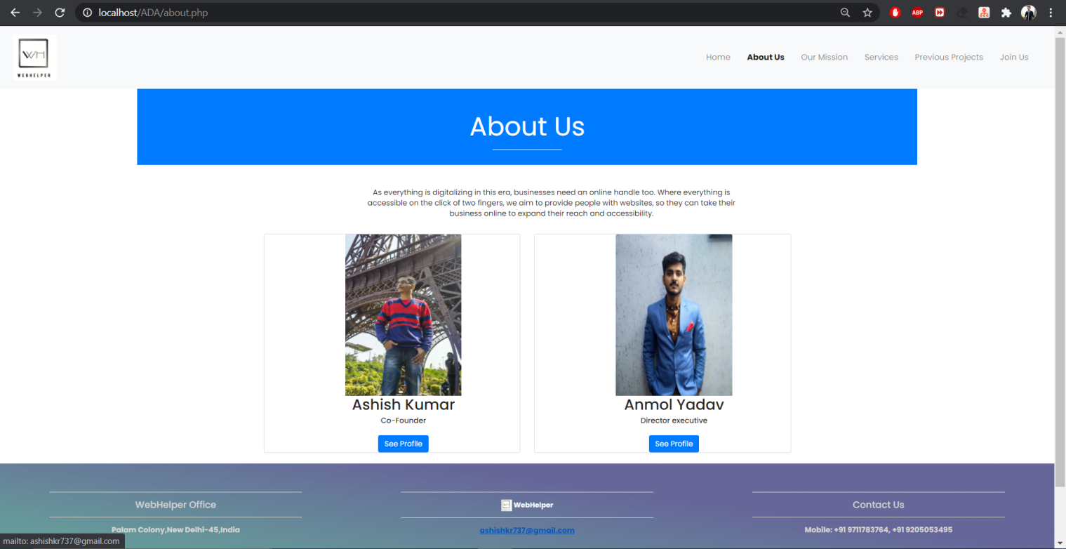

* This is Our mission page of our website
* A quote is displayed about websites in general.
* Then the aim of this startup is mentioned under ‘our mission’ heading, which highlights the basic idea behind our startup and our objectives of customer experience.

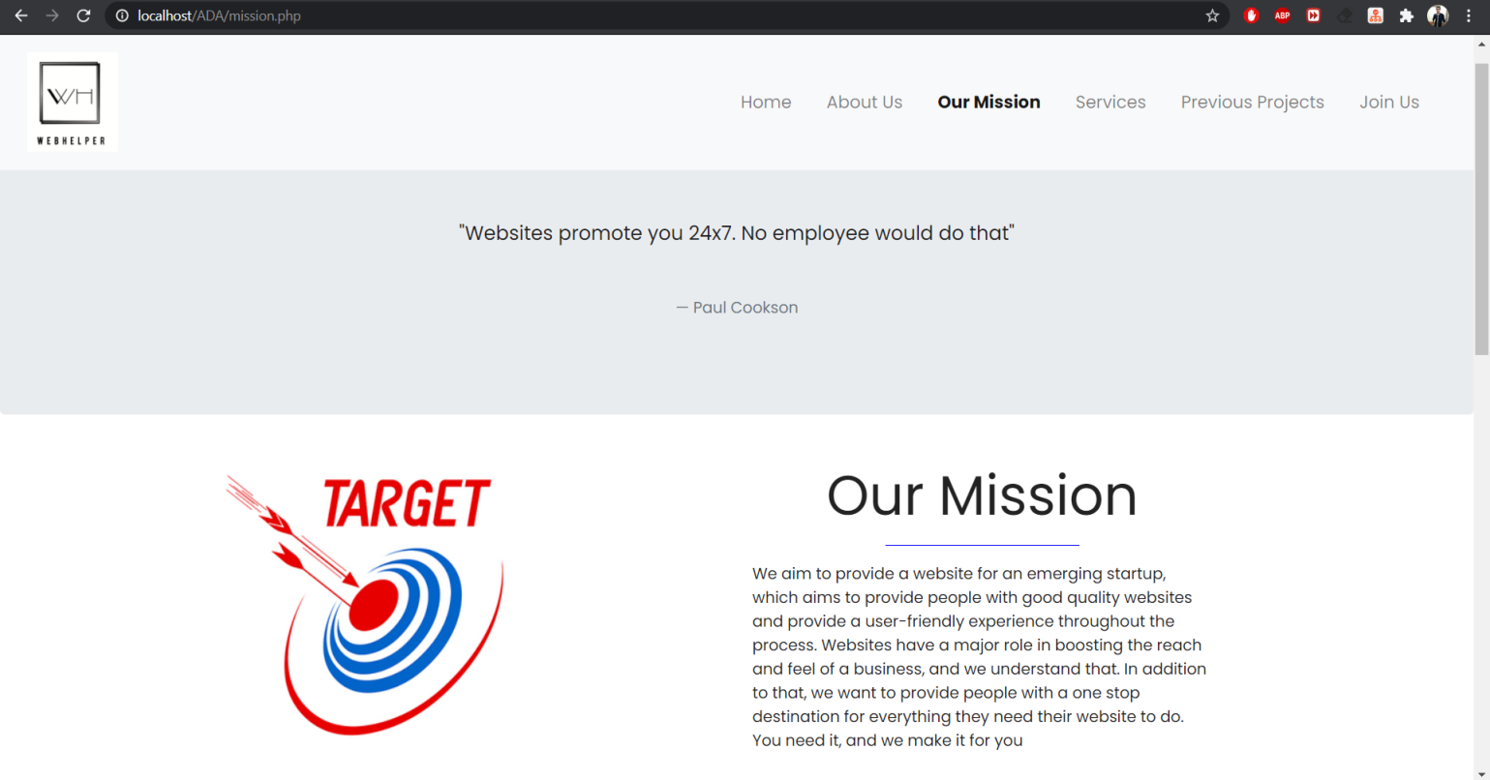

* Scrolling down we have mentioned 4 basic values behind our startup which are accountability, diligence, perseverance and integrity.
* WebHelper is a value driven company which guides the perspective of the organization as well as the actions.

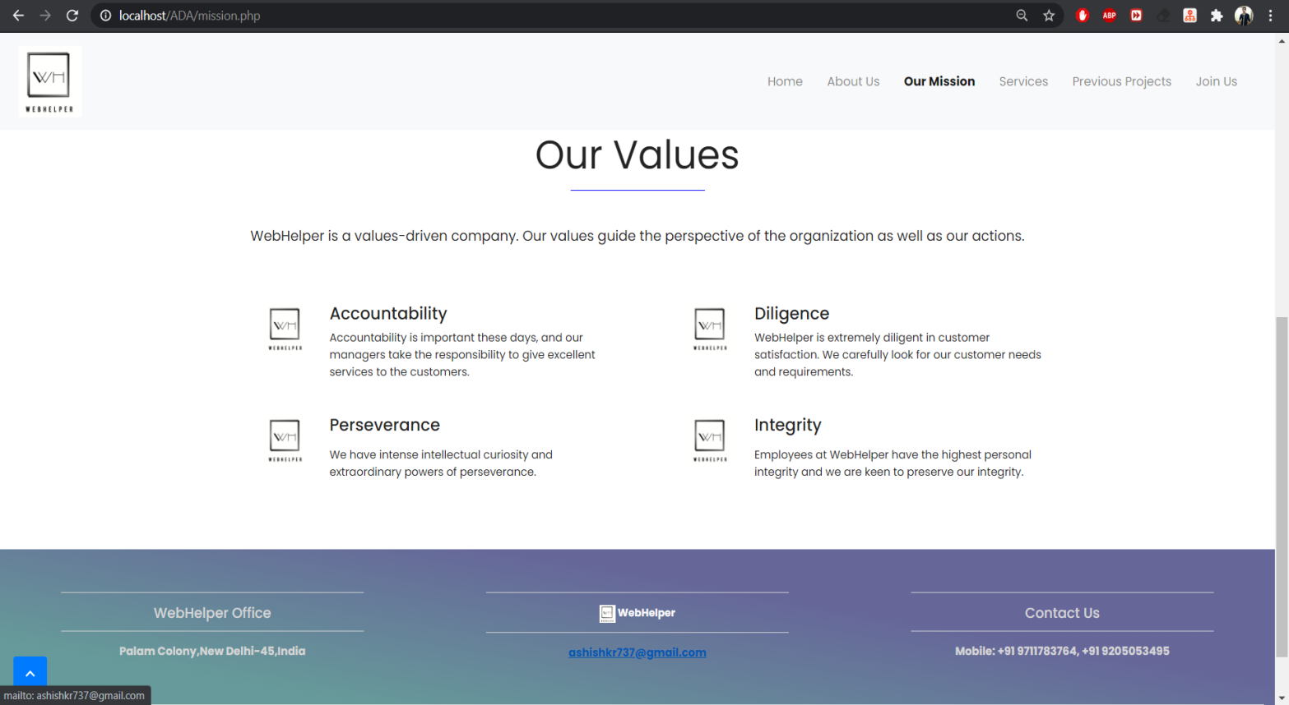

* This is Services page of our website
* On the top there is a quote from Laura Ashley.
* Then the services that we provide are mentioned under ‘our Services’ heading, which highlights what we do for the customers and how we make fully functional websites of any startup that customers are looking for.

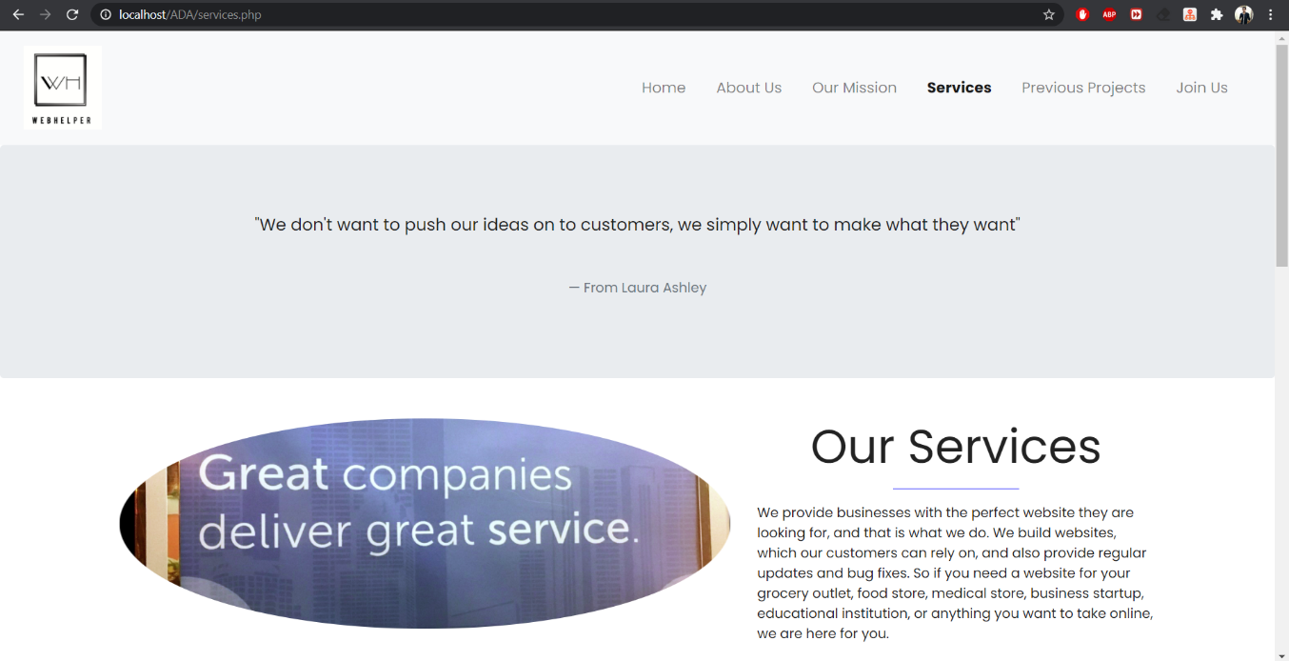

* Then on scrolling down, worth of products we provide is mentioned. We provide superior quality websites with costumer attractive ideas, fully functional, convenient to clients, easy to use.
* The site that we make for the clients is absolutely reliable in all the major aspects.

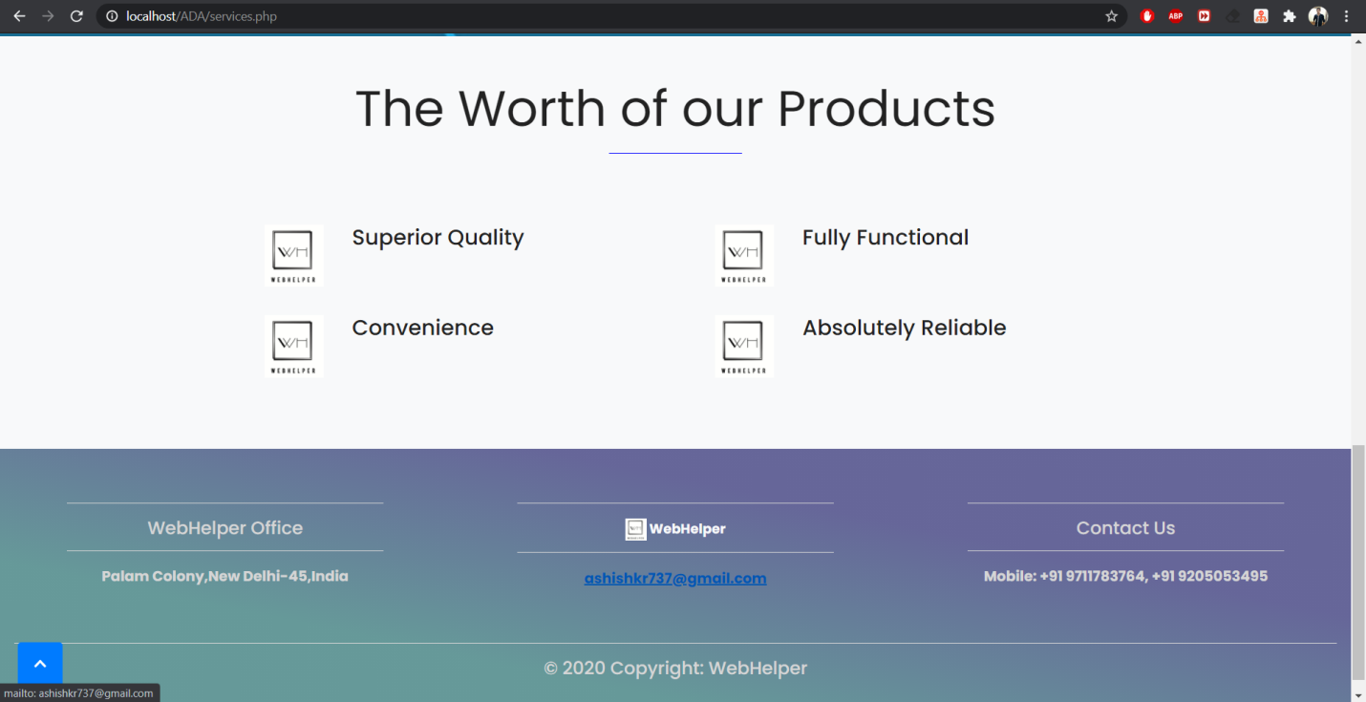

* This is Previous Project page of our website
* Clicking on previous projects option in the header redirects to github page where our previous projects are listed. User can browse through them and have a look at them.

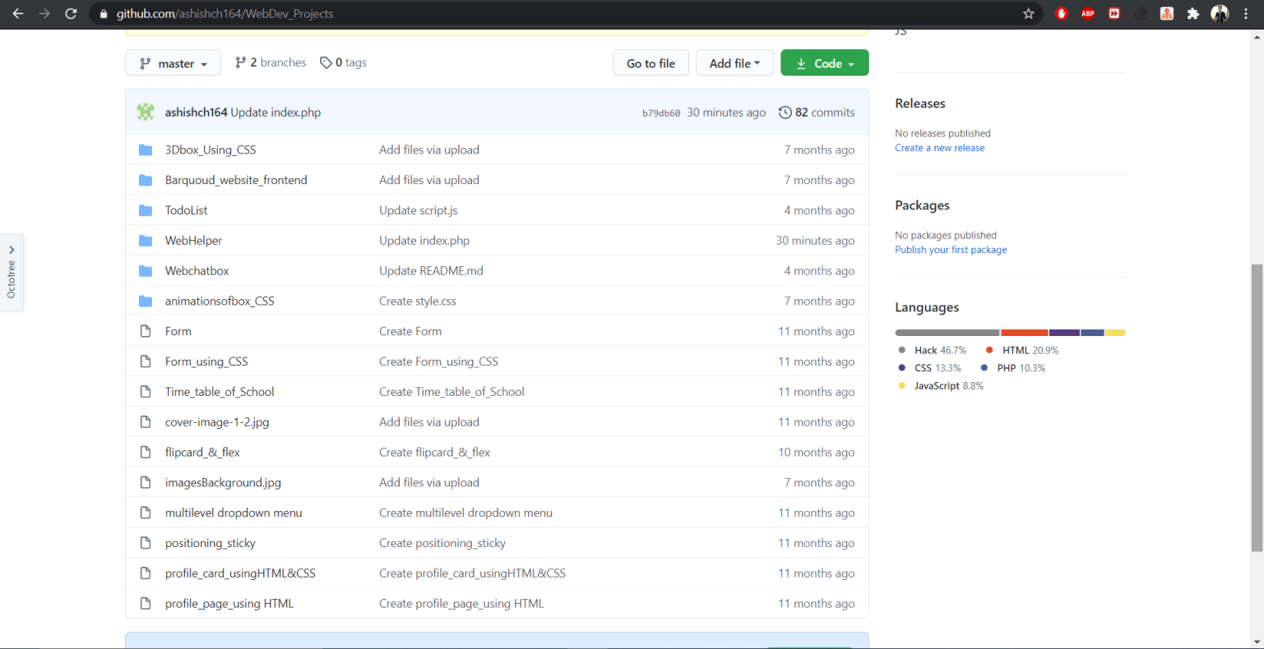

* This is Join Us page of our website
* Join us page is for the developers interested in working with our startup and for the users also who wants to make website for their company from us.
* A tab appears labeled as ‘wish to step forward with us’; clicking on which, a form appears.
* There are 5 fields to be entered by the user.
* Every field has validity checks.
* No field can be left empty or of invalid format.
* Submitting the form stores the entered data in the database, which is accessible to us. From there we can contact the person who submitted the form.

